Change Search Layout

Tax Code (Tax Procedure)

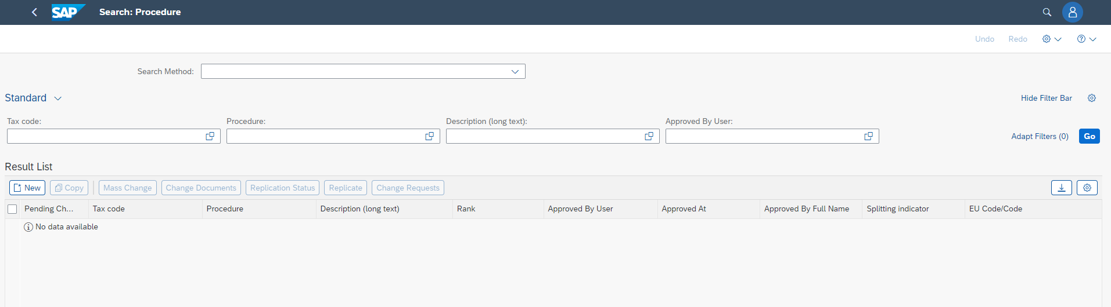
Example how to find the setting

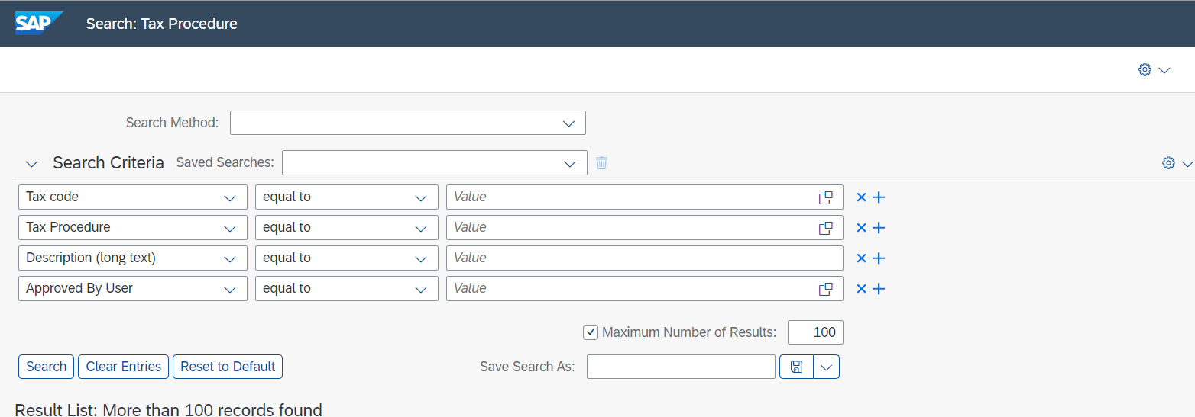

Right click
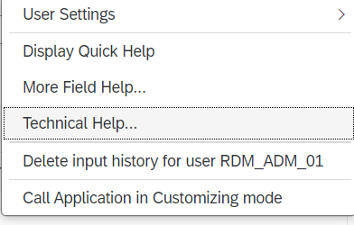

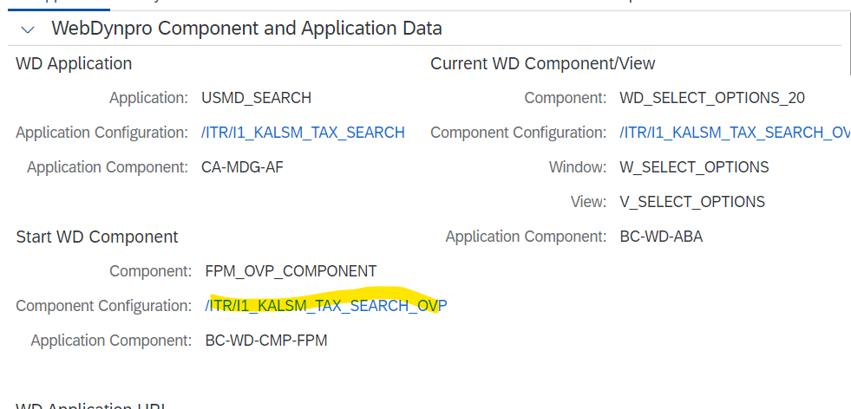

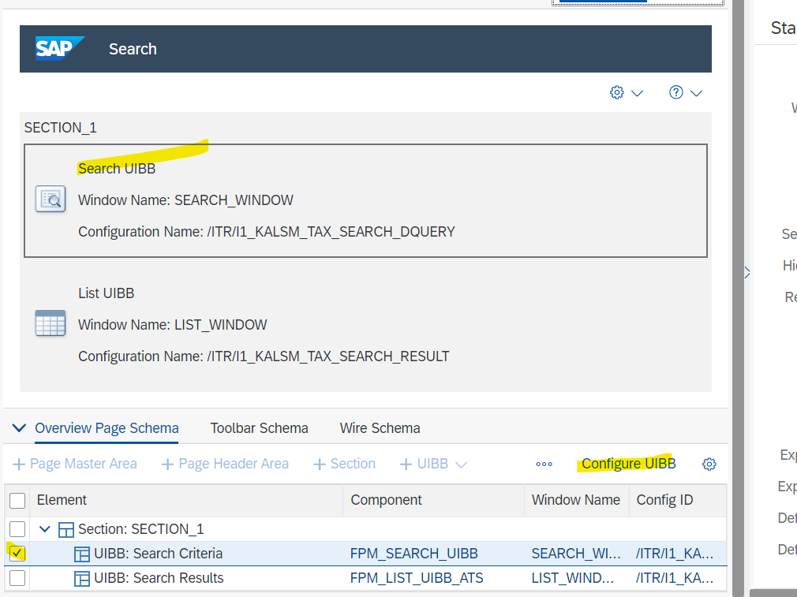

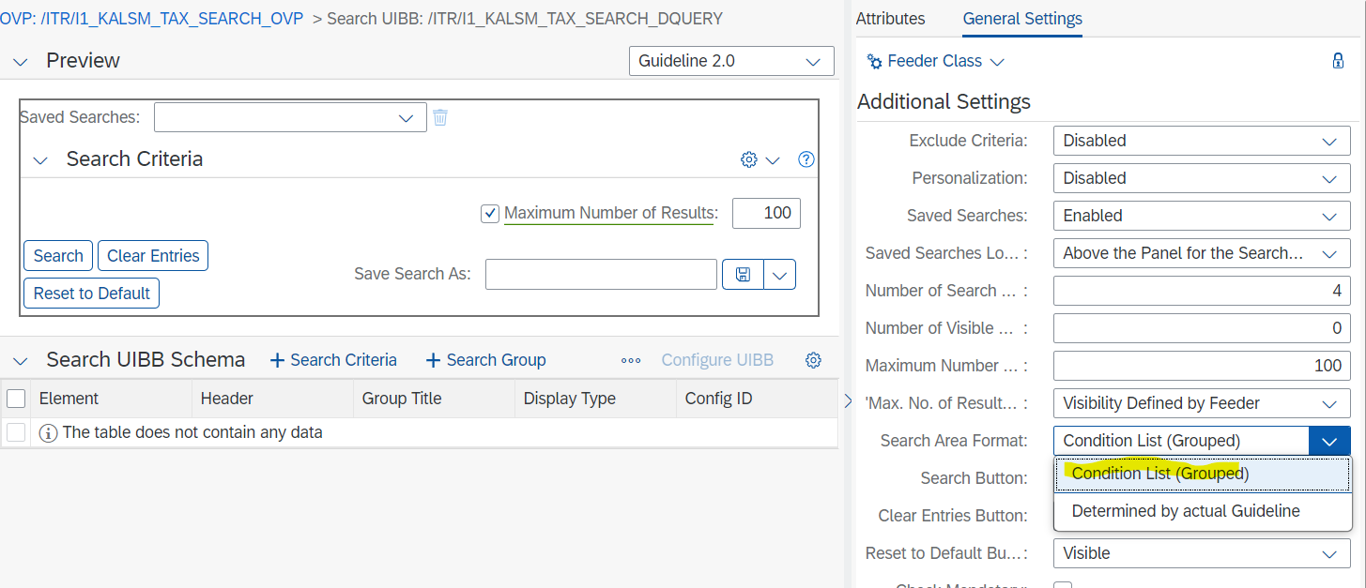
Marked: old style … “Condition List (Grouped)” … other allows to follow the guideline …
- Transport: IH1K900465 R2210: Search Format Alignment

Valuation Class
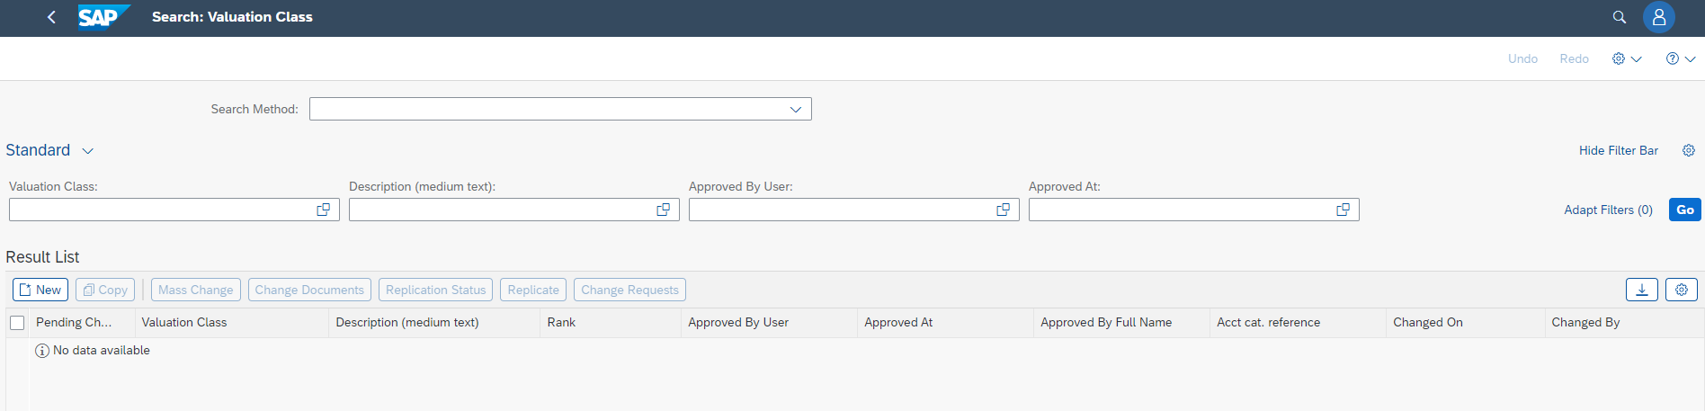

Marked: old style … “Condition List (Grouped)” … other allows to follow the guideline …
- Transport: IH1K900465 R2210: Search Format Alignment

And vendor acct group

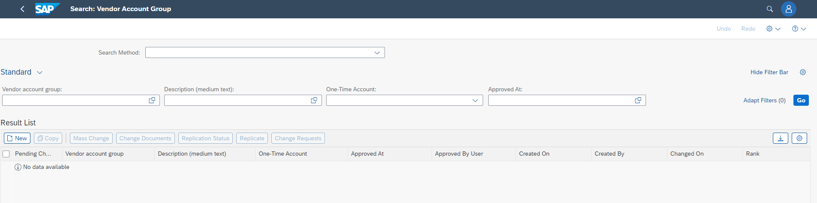

Marked: old style … “Condition List (Grouped)” … other allows to follow the guideline …
- Transport: IH1K900465 R2210: Search Format Alignment

Division
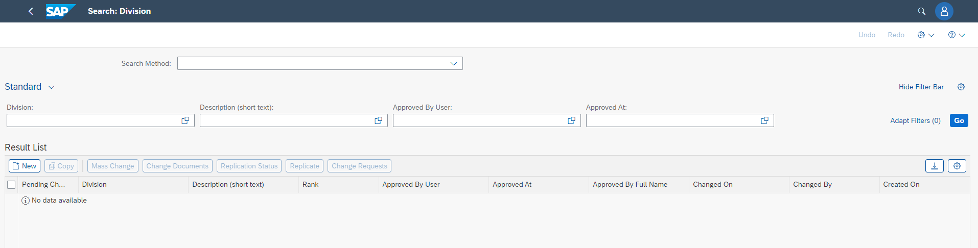
Marked: old style … “Condition List (Grouped)” … other allows to follow the guideline …
- Transport: IH1K900465 R2210: Search Format Alignment

Lab
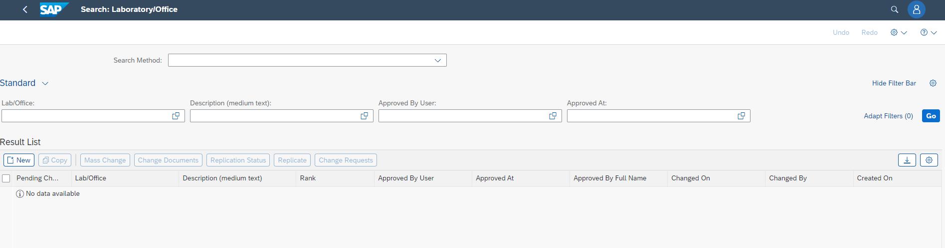

Marked: old style … “Condition List (Grouped)” … other allows to follow the guideline …
- Transport: IH1K900465 R2210: Search Format Alignment

MRP Area
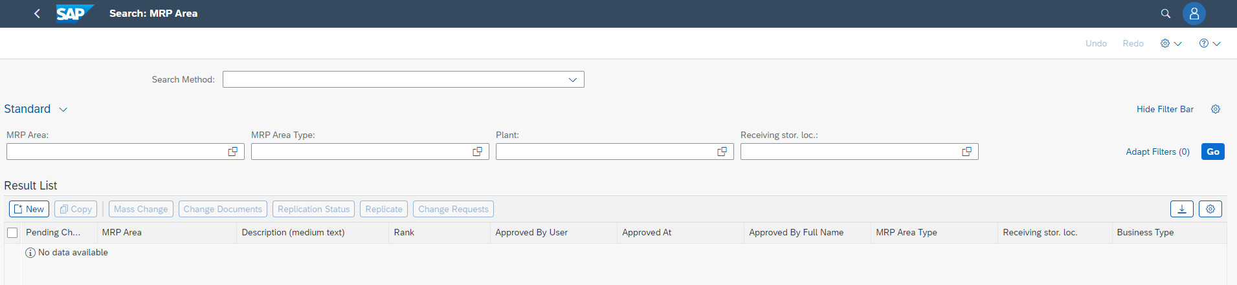

Marked: old style … “Condition List (Grouped)” … other allows to follow the guideline …
- Transport: IH1K900465 R2210: Search Format Alignment

Regions
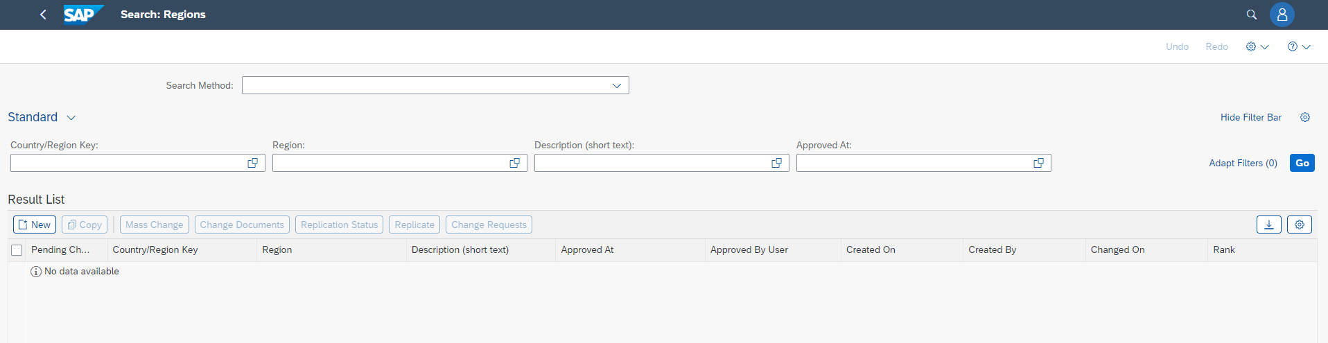

Marked: old style … “Condition List (Grouped)” … other allows to follow the guideline …
- Transport: IH1K900465 R2210: Search Format Alignment

Not possible to align for these objects!
Customer Account Group

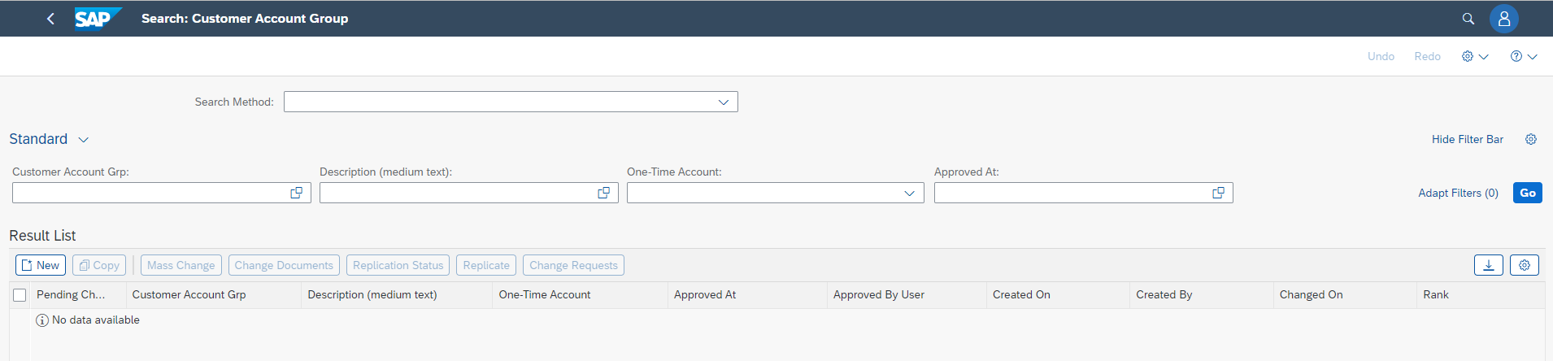
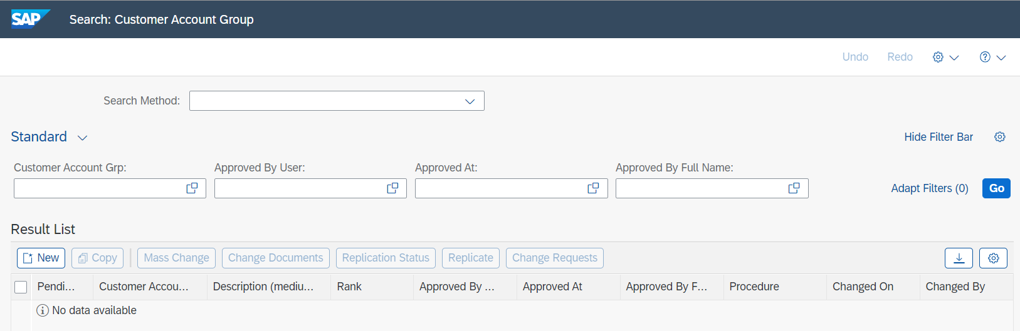
Right click

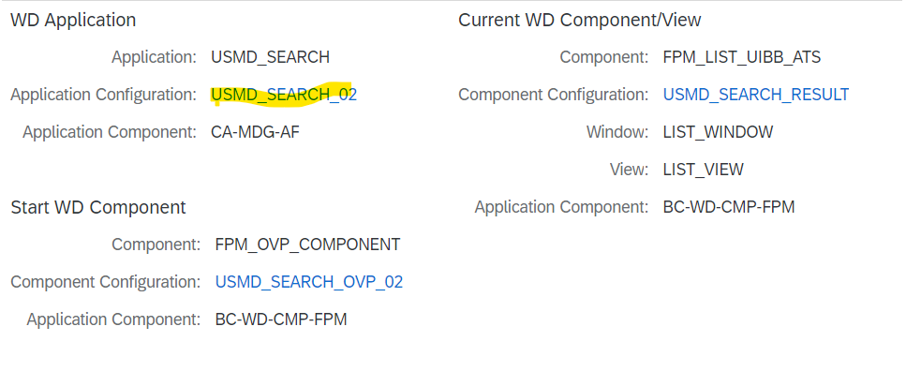

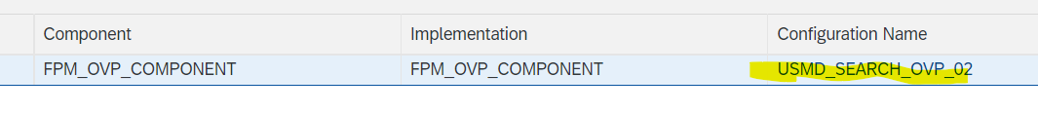
Dump

Also GL Account group

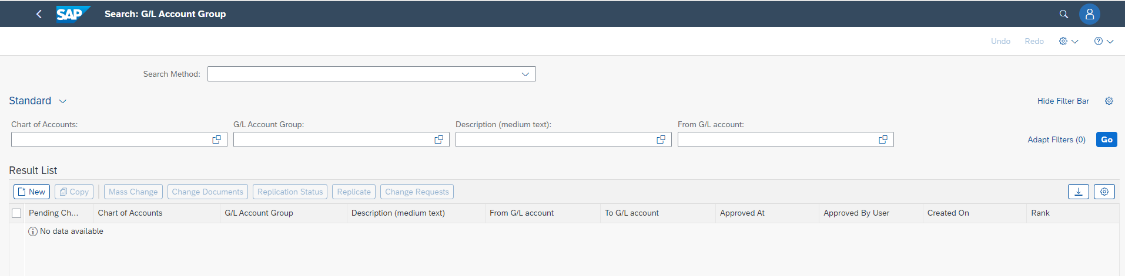
Dump

Payment Term Details
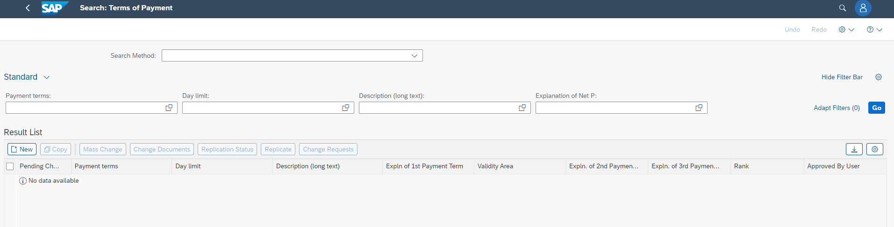

Product Hierarchy Nodes
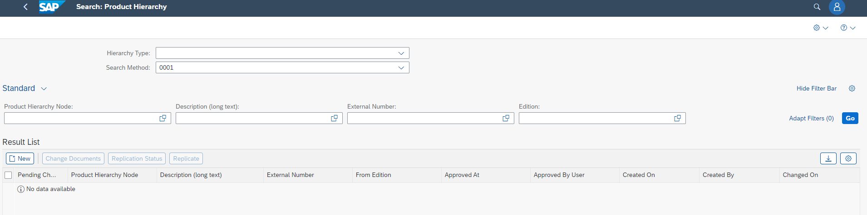
DUMP

